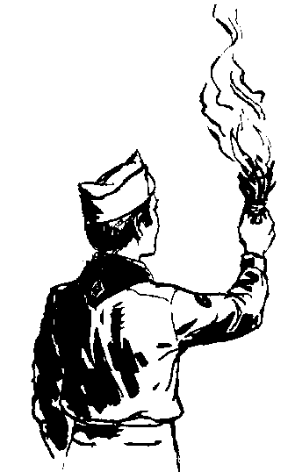

**Leading the way...**

|  |  |  |  |  |  |  |
| --- | --- | --- | --- | --- | --- | --- |
|  |  |  |  |  |  |  |
|  |  |  |  |  |  |  |
|  |  |  |  |  |  |  |

**Troop 93 Scout Leadership Positions**

**Duties and Responsibilities**



Leading the way...

What does that mean?

Think about being a Cub Scout. You came to den meetings and did a lot of different and fun things. But who decided what to do and who planned the activities? The Den Leaders, right?

Sports teams are a lot of fun, too. But who decides who plays what position, who's on the starting lineup and when to substitute? The coach, right?

There is one thing that makes Scouting different from all other youth groups. Do you know what it is?

Well, it is not the uniform. Every soccer, basketball, and baseball team has a uniform.  
 It is not the fun activities. There are a lot of other things that are fun.  
 And it certainly isn't cleaning dirty pots and pans on a campout.!!

**What makes Scouting special is that YOU make the decisions!**

That's right! YOU run the troop. Baden-Powell made it very plain in Aids to Scoutmastership when he wrote,

“The best progress is made in those Troops where power and responsibility are really put into the hands of the Patrol Leaders.”

This is real decision making power. And not it's not just Patrol Leaders. All of the troop leadership positions have a hand in making the Troop run. As a troop leader you will:

Plan and run troop meetings,  
Pick troop outings, where to camp, what to do,  
Plan advancement opportunities for all troop members  
Select High-Adventure programs  
Determine troop policy  
Help other Scouts along the trail to Eagle.

Sound cool? It really is! The adults are there to provide support but YOU will be making the decisions.

Being a leader is more than just sewing on a patch. We have put together job descriptions for the troop leadership positions. They will give you a good idea of what each job is all about and what you will be required to do.

Here is how to be considered for a position. First, read the job descriptions, qualifications, and job responsibilities. Then decide what you want to do and talk it over with your parents. You can also talk it over with other Scouts who have served in that position. Finally, get a troop job application form, fill it out, have your parent(s) read and sign it and turn it in.

So, are you ready to "Lead the way"? We sure hope so!



**Troop 93  
Leadership Position Description**

**TROOP LIBRARIAN**

**GENERAL INFORMATION**

**Type:** Elected by the Troop or appointed by the Senior Patrol Leader

**Term:** 6 months

**Reports to:** Assistant Senior Patrol Leader

**Description:** The Troop Librarian takes care of troop literature.

**Comments:** The library contains books of historical value as well as current materials. All together, the library is a troop resource worth hundreds of dollars. The Librarian manages this resource for the troop.

**QUALIFICATIONS**

**Age:** none

**Rank:** none

**Experience:** none

**Attendance:** 50% over the previous 6 months

**PERFORMANCE REQUIREMENTS**

**Training:** You must attend the troop Junior Leader Training even if you have attended in the past.

**Attendance:** You are expected to attend 60% of all troop meetings, Patrol Leaders' Council meetings, outings, and service projects. If your attendance is low, or if you have three (3) unexcused absences in a row, you can be removed from office.

**Effort:** You are expected to give this job your best effort.

**GENERAL LEADERSHIP RESPONSIBILITIES**

**Uniform:** Set the example by wearing your uniform correctly. This means that you will wear all of the parts of the troop uniform, shirttail tucked in, with all required badges in their correct locations.

**Behavior:** Set the example by living the Scout Oath and Law in your everyday life. Show Scout Spirit in everything you say and do.

**Attendance:** Set the example by being an active Scout. Be on time for meetings and activities. You must call the Senior Patrol Leader or Scoutmaster if you are not going to be at a meeting or if you suddenly have to miss an outing. You also need to make sure that someone will assume your responsibilities.

**SPECIFIC LEADERSHIP RESPONSIBILITIES**

Sets up and takes care of a troop library

Keeps records of books, merit badge books, and pamphlets owned by the troop.

Adds new or replacement items as needed.

Keeps books and pamphlets available for borrowing.

Keeps a system for checking books and pamphlets in and out.

Follows up on late returns.

Issues vouchers for purchase of used merit badge books.

**Troop 93  
  
Leadership Position Interest Application**

Your Name: Age:

Current Rank:

Current Position: Previous Positions:

Attendance (6 months): (get from Troop Scribe records)

List your first three choices

|  |  |  |
| --- | --- | --- |
| **1st Choice** | **2nd Choice** | **3rd Choice** |
|  |  |  |

For your first choice, use this space to tell why you want this job, how you would do the job, and why you are the best choice for this position.

Scout's Agreement

I have read the job descriptions for these positions. I understand the duties and responsibilities and if selected will carry them out to the best of my ability.

(Signature) (Date)

Parent's Support Agreement

I agree with the commitment my son is making. I promise to support him in attending training, troop meetings, and troop activities as well as with encouragement at home. I realize that once selected his presence is necessary for the smooth functioning of the troop.

(Signature) (Date)